Predictive maintenance for industrial motors

Problem statement
In industrial environments, motors are critical components that require continuous monitoring to ensure safe and efficient operation. However, many systems still rely on manual inspection or basic monitoring methods, which do not provide real-time insights into important parameters such as temperature, speed (RPM), and vibration.
This lack of real-time monitoring can lead to:
- Overheating and mechanical failures
- Unexpected breakdowns
- Increased maintenance costs
- Safety hazards
Therefore, there is a need for a system that can continuously monitor motor conditions in real time, detect abnormal behavior, and provide instant alerts to prevent failures and improve reliability.

Proposed Solution
To address the limitations of traditional motor monitoring systems, a real-time embedded monitoring solution is proposed using IoT and RTOS technologies.
The system uses an ESP32 microcontroller connected to sensors to continuously measure key parameters such as temperature, RPM, and vibration. This data is transmitted over WiFi to a QNX based server, where real-time processing is performed using message passing communication and multithreading.
The processed data is then uploaded to a cloud database (Firebase), enabling remote monitoring. An Android application is developed to display live motor conditions, including risk levels such as NORMAL, WARNING, ALERT.
This solution ensures continuous monitoring, quick detection of abnormal conditions, and remote accessibility, thereby improving safety, reducing downtime, and enhancing overall system reliability.

Why QNX is Better than Linux (for Our System)
Deterministic Real-Time Execution
QNX guarantees exact task timing
Linux is not strictly real-time (without RT patch)
➤ Ensures timely motor fault detection
Strict Priority-Based Scheduling
Uses SCHED_FIFO and priority control
High-priority tasks always execute first
➤ Critical alerts are never delayed
Efficient Message Passing IPC
Uses MsgSend() and MsgReceive()
No shared memory complexity
➤ Reliable and safe inter-process communication
Microkernel Architecture
Minimal kernel design
Better fault isolation
➤ System remains stable even if one module fails
Low Latency Performance
Designed for real-time embedded systems
Faster response than general-purpose OS
➤ Quick reaction to abnormal conditions
Industry-Level Reliability
Used in automotive, medical, and industrial systems
Proven for safety-critical applications
➤ Suitable for real-world deployment
Advanced Thread Control
Precise multithreading with real-time scheduling
Better control under high load
➤ Consistent and predictable system behavior

Arduino - code
#include <WiFi.h>
#include <HTTPClient.h>
#define LM35_PIN 34
#define IR_PIN 27
#define VIB_PIN 26
#define BUZZER_PIN 25
const char* SSID = "Darshan";
const char* PASSWORD = "0987654321";
const char* SERVER = "http://10.155.111.160:8080/data";
volatile uint32_t pulseCount = 0;
unsigned long lastRPMTime = 0;
uint32_t currentRPM = 0;
void IRAM_ATTR rpmISR()
{
pulseCount++;
}
float getTemp() {
int sum = 0;
for (int i = 0; i < 10; i++) {
sum += analogRead(LM35_PIN);
delay(1);
}
float avg = sum / 10.0;
float voltage = avg * (3.3 / 4095.0);
float temp = voltage * 100.0;
return temp;
}
uint32_t getRPM() {
unsigned long now = millis();
unsigned long elapsed = now - lastRPMTime;
if (elapsed >= 1000) {
currentRPM = (pulseCount * 60000UL) / elapsed;
pulseCount = 0;
lastRPMTime = now;
}
return currentRPM;
}
String getVibration() {
return digitalRead(VIB_PIN) == HIGH ? "YES" : "NO";
}
String getRisk(float temp, uint32_t rpm, String vib) {
bool t = temp > 60;
bool r = rpm > 3600;
bool v = vib == "YES";
if (t && r && v) return "HIGH ALERT";
if (t && r) return "ALERT";
if (t || r || v) return "WARNING";
return "NORMAL";
}
void setup() {
Serial.begin(115200);
delay(1000);
analogReadResolution(12);
pinMode(BUZZER_PIN, OUTPUT);
pinMode(IR_PIN, INPUT_PULLUP);
pinMode(VIB_PIN, INPUT_PULLUP);
attachInterrupt(digitalPinToInterrupt(IR_PIN), rpmISR, RISING);
WiFi.begin(SSID, PASSWORD);
Serial.print("Connecting WiFi");
while (WiFi.status() != WL_CONNECTED) {
delay(500);
Serial.print(".");
}
Serial.println("\nWiFi Connected: " + WiFi.localIP().toString());
Serial.println("─────────────────────────────────────");
lastRPMTime = millis();
}
void loop() {
float temp = getTemp();
uint32_t rpm = getRPM();
String vib = getVibration();
String risk = getRisk(temp, rpm, vib);
Serial.println("─────────────────────────────────────");
Serial.print (" Temperature : "); Serial.print(temp, 1); Serial.println(" °C");
Serial.print (" RPM : "); Serial.println(rpm);
Serial.print (" Vibration : "); Serial.println(vib);
Serial.print (" Risk : "); Serial.println(risk);
if (risk == "HIGH ALERT") { tone(BUZZER_PIN, 1000); }
else if (risk == "ALERT") { tone(BUZZER_PIN, 500); }
else { noTone(BUZZER_PIN); }
if (WiFi.status() == WL_CONNECTED) {
HTTPClient http;
http.begin(SERVER);
http.addHeader("Content-Type", "application/json");
http.setTimeout(1500);
String body = "{";
body += "\"temp\":" + String(temp, 1) + ",";
body += "\"rpm\":" + String(rpm) + ",";
body += "\"vibration\":\"" + vib + "\",";
body += "\"risk\":\"" + risk + "\"";
body += "}";
http.POST(body);
http.end();
}
delay(500); // update every 500ms = real-time feel
}

QNX - Code
#include <stdio.h>
#include <stdlib.h>
#include <string.h>
#include <unistd.h>
#include <arpa/inet.h>
#include <sys/socket.h>
#include <netinet/in.h>
#include <curl/curl.h>
#include <pthread.h>
#include <sched.h>
#include <sys/neutrino.h>
typedef struct {
float temp;
int rpm;
char vibration[10];
char risk[20];
} sensor_data_t;

int chid;
void set_priority()
{
struct sched_param param;
param.sched_priority = 20;
if (pthread_setschedparam(pthread_self(), SCHED_FIFO, &param) != 0)
{
perror("Failed to set priority");
}
else
{
printf("[INFO] Real-time priority enabled\n");
}
}
void* processing_thread(void* arg)
{
int rcvid;
sensor_data_t data;
while (1)
{
rcvid = MsgReceive(chid, &data, sizeof(data), NULL);
if (rcvid <= 0) continue;
printf("[PROCESS] Temp: %.1f | RPM: %d | Vib: %s | Risk: %s\n",
data.temp, data.rpm, data.vibration, data.risk);
char json[256];
sprintf(json,
"{ \"temp\": \"%.1f\", \"rpm\": \"%d\", \"vibration\": \"%s\", \"risk\": \"%s\" }",
data.temp, data.rpm, data.vibration, data.risk);
CURL *curl = curl_easy_init();
if (curl)
{
curl_easy_setopt(curl, CURLOPT_URL,
"https://industrial-motor-default-rtdb.firebaseio.com/.json");
curl_easy_setopt(curl, CURLOPT_CUSTOMREQUEST, "PUT");
curl_easy_setopt(curl, CURLOPT_POSTFIELDS, json);
curl_easy_setopt(curl, CURLOPT_SSL_VERIFYPEER, 0L);
if (curl_easy_perform(curl) == CURLE_OK)
{
printf("[INFO] Firebase updated\n");
}
else
{
printf("[ERROR] Firebase update failed\n");
}

curl_easy_cleanup(curl);
}

MsgReply(rcvid, 0, NULL, 0);
}
}
void* handle_client(void* arg)
{
int client_fd = *(int*)arg;
free(arg);
char buffer[4096];
int total = 0;
while (1)
{
int n = read(client_fd, buffer + total, sizeof(buffer) - total - 1);
if (n <= 0) break;
total += n;
}
buffer[total] = '\0';
sensor_data_t data;
char *json_start = strstr(buffer, "{");
if (json_start)
{
sscanf(json_start,
"{\"temp\":%f,\"rpm\":%d,\"vibration\":\"%[^\"]\",\"risk\":\"%[^\"]\"}",
&data.temp, &data.rpm, data.vibration, data.risk);
printf("[RECV] Temp: %.1f | RPM: %d\n", data.temp, data.rpm);
int coid = ConnectAttach(0, 0, chid, 0, 0);
if (coid != -1)
{
MsgSend(coid, &data, sizeof(data), NULL, 0);
ConnectDetach(coid);
}
}
const char *response = "HTTP/1.1 200 OK\r\nContent-Length: 2\r\n\r\nOK";
write(client_fd, response, strlen(response));

close(client_fd);
return NULL;
}
int main()
{
set_priority();
chid = ChannelCreate(0);
if (chid == -1)
{
perror("Channel creation failed");
return -1;
}
pthread_t proc_thread;
pthread_create(&proc_thread, NULL, processing_thread, NULL);
int server_fd;
struct sockaddr_in addr;
int addrlen = sizeof(addr);
server_fd = socket(AF_INET, SOCK_STREAM, 0);
if (server_fd < 0)
{
perror("Socket creation failed");
return -1;
}
addr.sin_family = AF_INET;
addr.sin_addr.s_addr = INADDR_ANY;
addr.sin_port = htons(8080);
if (bind(server_fd, (struct sockaddr *)&addr, sizeof(addr)) < 0)
{
perror("Bind failed");
return -1;
}
listen(server_fd, 5);
printf("[INFO] Server started on port 8080...\n");
while (1)
{
int *client_fd = (int*) malloc(sizeof(int));
*client_fd = accept(server_fd,
(struct sockaddr *)&addr,
(socklen_t*)&addrlen);
if (*client_fd < 0) {
perror("Accept failed");
free(client_fd);
continue;
}
printf("[INFO] ESP32 connected\n");
pthread_t tid;
pthread_create(&tid, NULL, handle_client, client_fd);
pthread_detach(tid);
}
close(server_fd);
return 0;
}

System architecture

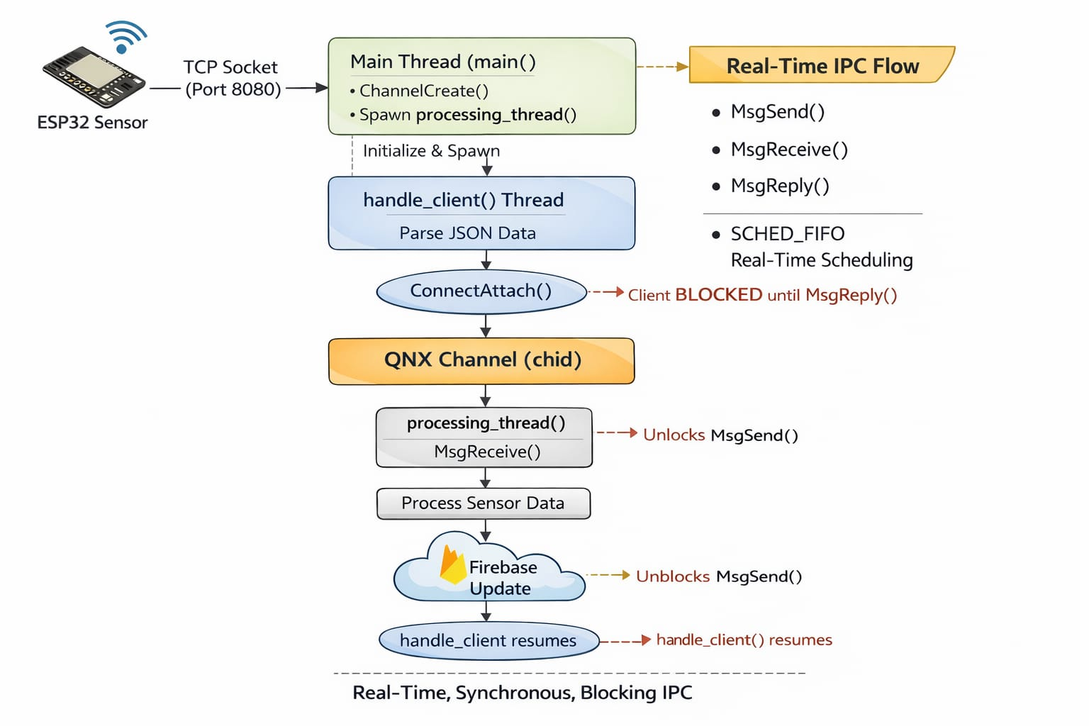

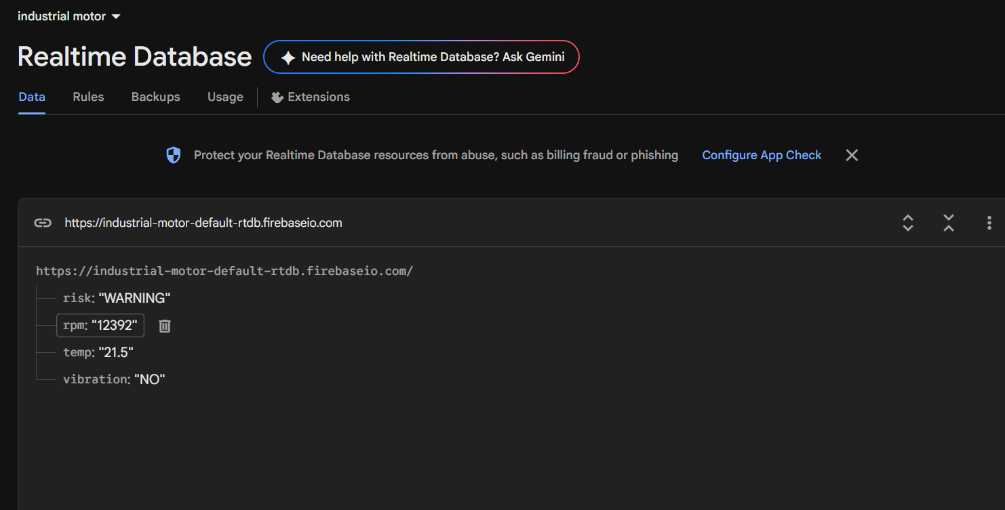

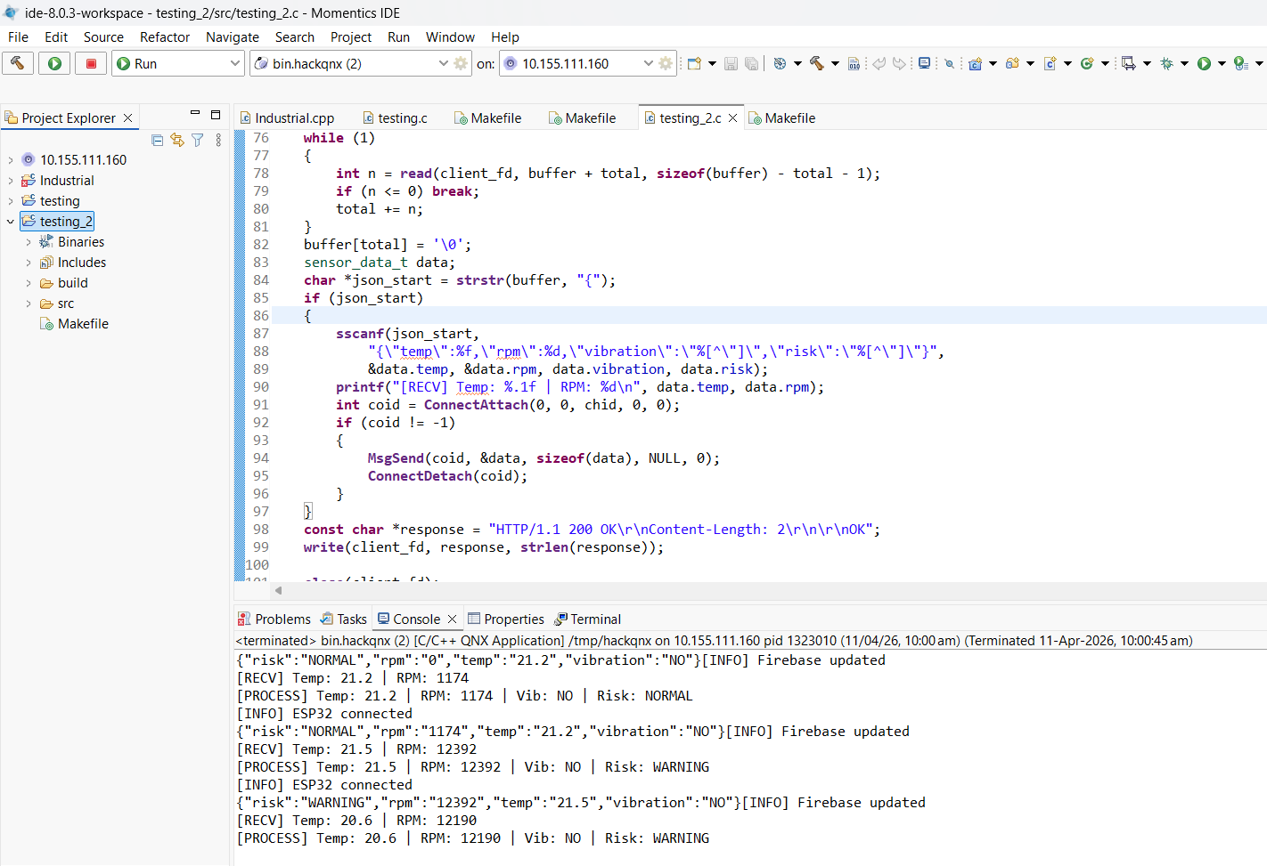

Conclusion
The developed system successfully demonstrates a real-time industrial motor monitoring solution using embedded systems, IoT, and RTOS concepts. By integrating sensors with the ESP32, important parameters such as temperature, RPM, and vibration are continuously monitored and transmitted for processing.
The use of a QNX based server ensures reliable and deterministic data handling through message passing and multithreading. The integration with Firebase and an Android application enables remote monitoring and easy visualization of motor conditions. The system is capable of identifying different risk levels and providing timely alerts, helping to prevent potential failures.
Overall, the project provides an efficient, scalable, and cost effective solution for real time motor health monitoring, with potential for further enhancement using advanced analytics and predictive maintenance techniques.

